STUDENT
 |  |  |  | 20% will be deducted from scores for each week late  Score = Points awarded (Pts) x Weight (Wt)
  I am submitting my own work, and I understand penalties will
  be assessed if I submit work for credit that is not my own.
   | Print Name |  | ID Number
   | Sign Name |  | Date
   | Estimated Work Hours |  |  |  |  |  |  |  |  |  | Point Scale
   | 1 | 2 | 3 | 4 | 5 | 6 | 7 | 8 | 9 | 10
   | 1 | 2 | 3 | 4 | 5 | 6 | 7 | 8 | 9 | 10
   | Overall Weight
  4: Exemplary
  3: Complete
  2: Incomplete
  1: Minor effort
  0: Not submitted
LAB ASSISTANT |  |  |  |  |  |  |  |  | Total In-Lab
 |  |  |  |  |  |  |  |  | Score
  # | Demonstration | Wt | Pts | Late | Score | Lab Asst Signature | Date
  1 | Demo one truth table | 3
GRADER |  |  | Weeks |  | Total |  |  | Total score is In-lab score plus grading score | Total
 |  |  | late |  | Grading Score |  |  | Total score is In-lab score plus grading score | Score
  # | Attachments | Wt | Pts | Score
  1 | Worksheet | 4

Introduction

In this lab project, you will download a .bit file to your board to configure the FPGA with eight different logic circuits. The circuits use buttons and switches for inputs, and LEDs for outputs. You must probe the logic circuits by applying all possible combinations of input signals, and from the results write logic equations that describe the circuit’s behavior.

Problem 1. Obtain the file “lab1_boardname.bit” from the class website, and download it to your Digilent board following the procedure in Appendix A below. Your board will be configured with eight logic circuits that drive the eight on-board LEDs. You must find logic equations to describe the circuits. After the FPGA is configured with the bit file, apply all combinations of relevant inputs (hint: see the input variable names on the top row of each truth table), and use the output LED status to complete the following truth tables. Have the lab assistant inspect your work.

swt7 | btn3 | LED7
L | L
L | H
H | L
H | H

LED7 <=
swt6 | btn3 | LED6
L | L
L | H
H | L
H | H

LED6 <=

swt7 | swt6 | swt5 | LED5
L | L | L
L | L | H
L | H | L
L | H | H
H | L | L
H | L | H
H | H | L
H | H | H

LED5 <=
btn3 | btn2 | LED4
L | L
L | H
H | L
H | H

LED4 <=

swt4 | swt3 | btn1 | LED3
L | L | L
L | L | H
L | H | L
L | H | H
H | L | L
H | L | H
H | H | L
H | H | H

LED3 <=
swt2 | btn0 | LED2
L | L
L | H
H | L
H | H

LED2 <=

btn1 | btn0 | LED1
L | L
L | H
H | L
H | H

LED1 <=
swt2 | swt1 | swt0 | LED0
L | L | L
L | L | H
L | H | L
L | H | H
H | L | L
H | L | H
H | H | L
H | H | H

LED0 <=

Appendix A. Programming Digilent Boards Using Adept

Adept™ is a suite of Windows-based applications that can transfer programming files and other data between a PC and Digilent boards. Adept typically uses a USB2 port for communications, but Ethernet, Serial, and Parallel ports are also supported.

Applications in the Adept suite include ExPort for transferring programming files, TransPort for moving user-data to and from devices on Digilent boards, USB Administrator for modifying USB port settings, and Ethernet Administrator for modifying Ethernet port settings. Although Adept is flexible enough to support many specific end-user requirements, most users can install Adept with default settings and immediately begin programming devices using a USB port.

This document provides a brief tutorial demonstrating the installation and basic use of Adept. For more complete information, please visit our website at www.digilentinc.com.

Installing Adept

Adept Suite is compatible with Windows 2K, XP, and Vista. The Adept Suite installer will install the ExPort, TransPort, Ethernet Administrator, and USB Administrator applications as well as the USB driver. To install the Adept Suite, you must log on to your PC as an Administrator, disconnect any USB devices connected to the PC, and run the DASV1-9-1.msi file. Then, follow the instructions below.

- When the installer application opens, click “Next” | 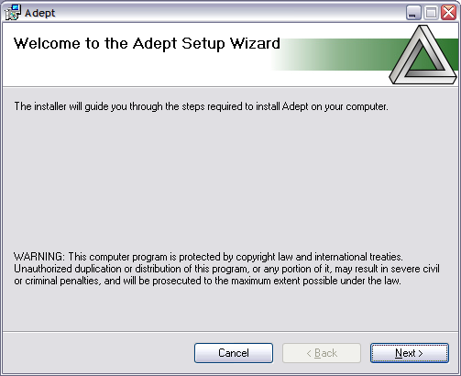

- Read the EULA, click the “I Agree” radio button and click “Next”. | 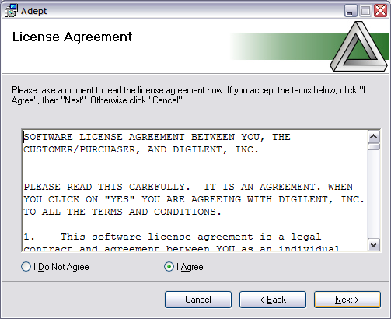
- We recommend installing Adept Suite for “Everyone”. | 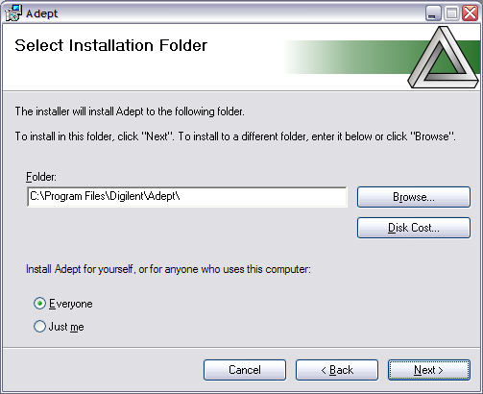
- Click “Next” to start the installation. | 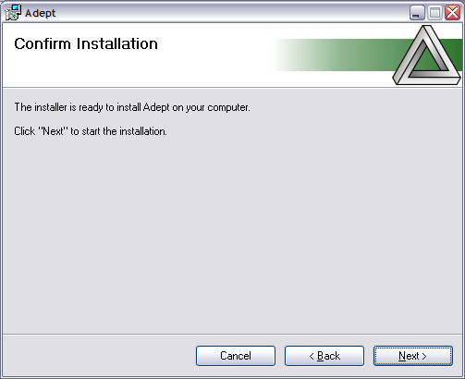
- The Digilent USB driver is not signed by Microsoft. Although it is completely safe and will not harm your computer, Windows will warn about installing it. Click the “Continue Anyway” button. | 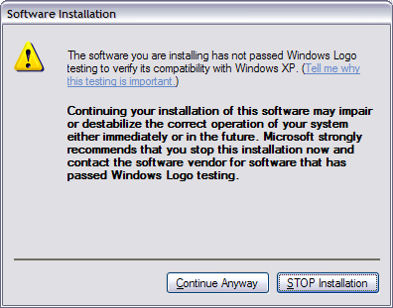
- Click the “OK” button to finish installation. | 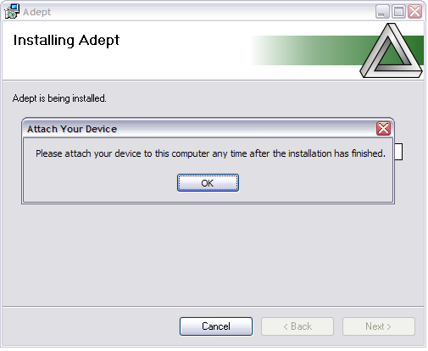
7. Connect board to PC via USB cable. Windows should recognize the device. | 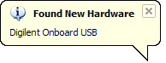
- The Found New Hardware Wizard will appear. Select “No, not this time” and click the “Next” button. | 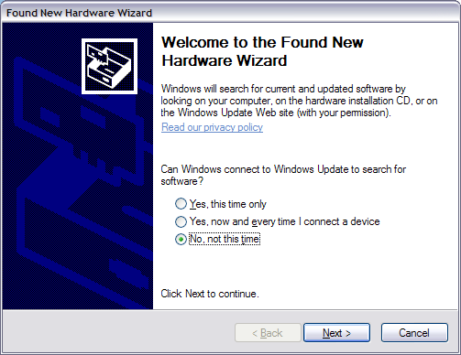
- Set the wizard to “Install the software automatically”. Click the “Next” button. | 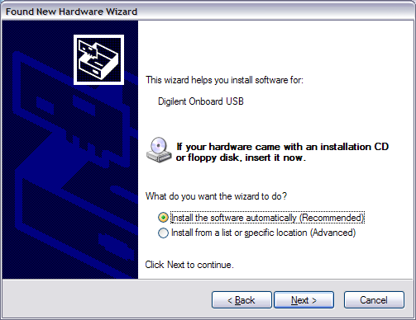
- Windows will again prompt you with the warning about the unsigned USB driver. Once again, click “Continue Anyway” to allow the installation to complete.

Using ExPort

- Open ExPort.

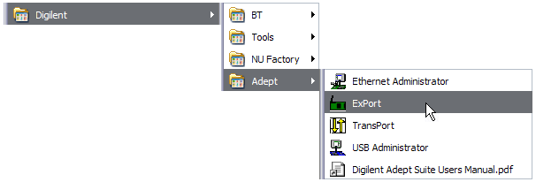

- To Initialize the Scan Chain for programming, make sure the “Auto-Detect USB” box is checked and Click “Initialize Chain”. | 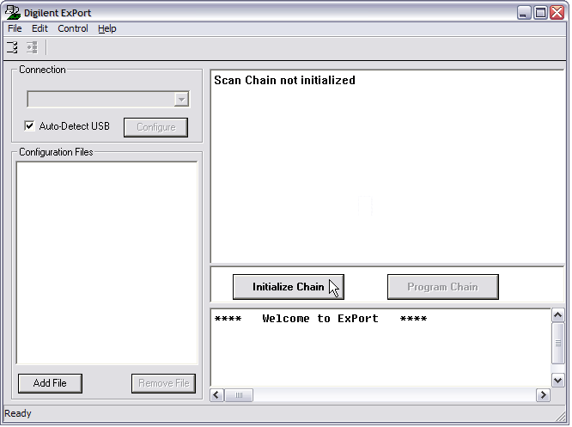
- After scan-chain initialization, devices can be programmed, erased, and verified. To program a device, assign a configuration file to the device in the pull-down box. To add a file, click the “Browse…” button and navigate to the desired file. | 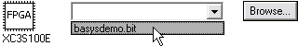
- After the programming file has been selected, right-click on the device icon and select “Program Device”. | 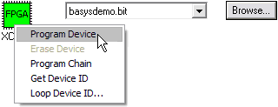
- An on-screen message will tell you if programming was successful. If programming is not successful, ensure the board is properly powered and that all cable connections are intact, and try again. | 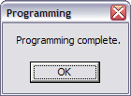

For more information on ExPort and all other Adept applications, please see the Digilent Adept Suite Users Manual.

